Writing Task One 议论文写作（Argumentative Writing）
比赛内容：选手完成一篇议论文写作（450-500词）。侧重考查选手的文献阅读理解、信息综合处理、判断分析、逻辑思辨、评价论述等能力，展示选手的知识 广度、视野维度、思想深度等综合素质。
评分标准（总分50分）：
Argumentative Writing
Content/Ideas  (40%) | 1. Writing effectively addresses the topic and the task;  2. Writing presents an insightful position on the issue;  3. The position is strongly and substantially supported or argued.
Organization/ Development  (30%) | 1. Writing is well-organized and well-developed, using appropriate rhetorical devices (e.g. exemplifications, classification, analysis, comparison/contrast, etc.) to support the thesis or to illustrate ideas;  2. Writing displays coherence, progression, consistency and unity;  3. Textual elements are well-connected through explicit logical and/or linguistic transitions.
Language  (30%) | 1. Spelling is accurate;  2. Writing displays consistent facility in use of language;  3. Writing demonstrates appropriate register, syntactic variety, and effective use of vocabulary.

Task 1
Read the following statement and write a passage about the issue, clearly stating your opinion and explaining your reasons with examples taken from your reading, studies, experience, or observations. You should write about 500 words. (Suggested completion time: 90 minutes)

Everybody has some choice. People are always blaming their circumstances for what they are. I don’t believe in circumstances. The people who get on in this world are the people who get up and look for the circumstances they want and, if they can’t find them, make them.

Writing Task Two说明文写作（Expository Writing）
比赛内容：选手完成一篇说明文写作（300-400词）。侧重考查选手解说事物、阐明事理的能力，以及运用知识、观察理解、梳理分析、提炼总结、跨文化沟通的综合能力。
评分标准（总分50分）：
Expository Writing
Content/Ideas  (40%) | 1. Writing effectively addresses the topic and the task;  2. Writing presents a clear thesis;  3. Writing maintains a formal style and an objective tone.
Organization/ Development  (30%) | 1. Writing is well-organized and well-developed, using appropriate development patterns (e.g., definition, illustration, casual analysis, process analysis, classification, comparison/contrast, etc.) to support the thesis or to illustrate ideas;  2. Writing displays coherence, progression, consistency and unity;  3. Textual elements are well-connected through explicit logical and/or linguistic transitions.
Language  (30%) | 1. Spelling is accurate;  2. Writing displays consistent facility in use of language;  3. Writing demonstrates appropriate register, syntactic variety, and effective use of vocabulary.
task 2
Write a passage based on the chart below. The chart shows the hourly AQI (Air Quality Index) in Beijing, Shanghai and Guangzhou on the same day. In your writing, you should summarize the information by selecting and reporting the main features and make comparisons where relevant. You should write 300-400 words . (Suggested completion time: 60 minutes)
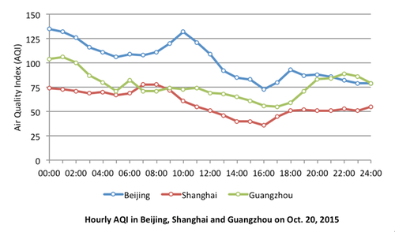
Note: AQI | 0-50 | Good
 | 51-100 | Moderate
 | 101-150 | Lightly polluted
 | 151-200 | Moderately polluted
 | 201-300 | Heavily polluted
 | >300 | Severely polluted

